

Data sheets
of the raw material of heavy concrete called BARITMIX-1

Contents:
Contents: 2
1. Material safety data sheet of BARITMIX-1 3
2. Technical data sheet of BARITMIX-1 7
3. Data sheet of BARITMIX-1 9

Attachments - Material test

Test of the heavy concrete 10
TEST OF X-RAY DIFFACTION 13
on the tests of the additive of the refuse pile of Rudabánya-II called BARITMIX 1 required for the production of heavy concrete 16
1. INTRODUCTION 18
2. THE TEST OF THE ADDITIVE CALLED BARITMIX 1 18
2.1. The tests of the raw material 18
3. TEST OF CONCRETES MADE OF BARITMIX 1 23
3.1. The features of the fresh concrete 23
Exploitation of the refuse pile of Rudabánya-II 28

1. Material safety data sheet of BARITMIX-1
1. IDENTIFICATION OF THE PREPARATION: BARITMIX-1
Product number: RBB-3100-0,00-12

1.1. Intended use: for industrial application

1.2. Name of the manufacturer / supplier: Pólus Kincs Zrt
H-2132 Göd, Kádár utca 49.
Phone: (+36 27) 530-530 Fax: (+36 27) 530-530

1.4. Responsible person: László Juhász, grad. geologist
Phone: +36-30-290-5655
E-mail: juhaszlaszlo@poluskincs.hu

1.5. Emergency telephone number: Egészségügyi Toxikológiai Tájékoztató Szolgálat (ETTSZ)
1096 Budapest, Nagyvárad tér 2.
Phone: (36 1) 476 6464, (36 80) 201 199

2. HAZARDS IDENTIFICATION
Non hazardous preparation.

  - Information concerning specific hazards for human and environment:
Mixture of slightly soluble substances. Barite and quartz are insoluble in water; dolomite is soluble in acids, but poses no hazards to the environment. Iron minerals are slightly soluble.

- COMPOSITION / INFORMATION ON INGREDIENTS

This product contains no hazardous materials.
Description: Unclassified ground material with a grain size of 0.00 - 12 mm containing 15 - 20 % of barite.

- FIRST AID MEASURES

INFORMATION TO THE PHYSICIAN: No specific prescriptions. In case of ingestion the product will be excreted through the gastro-intestinal tract without causing any symptoms. Decomposition of calcite and dolomite due to gastric acid may result fever and vomiting.
  - IN CASE OF INGESTION:
Measures:
- Never give anything by mouth and do not induce vomiting if the affected person is unconscious.
- Ingestion provokes no symptoms.
- If symptoms occur call a physician immediately and show him label.
4.2. IN CASE OF INHALATION:
Measures:
- In case of inhalation of dust move affected person into fresh air, loosen clothing and allow to rest.
- If symptoms occur, consult a physician.
4.3. IN CASE OF SKIN CONTACT:
Measures:
- Remove contaminated clothes immediately.
- Wash skin with copious amount of water and soap (for at least 15 minutes).
- If symptoms occur, consult a physician.
4.4. IN CASE OF EYE CONTACT:
Measures:
- In case of contact with eyes flush immediately with plenty of flowing water for 15 minutes holding eyelids apart.
- If symptoms occur, consult a physician.

5. FIRE-FIGHTING MEASURES
Not flammable!
5.1. Suitable extinguishing media:
Product is non combustible.
5.2. Unsuitable extinguishing media for safety reasons:
None known.
5.3. Special protective equipment:
Wear the usual full-protective clothing.
5.4. Hazardous combustion products:
Product is non combustible.
5.5. Other:
Collect extinguishing water separately. Allow only pre-treated extinguishing water to enter sewage system. Product is non combustible.

6. ACCIDENTAL RELEASE MEASURES
  - PERSONAL PRECAUTIONS:
Keep unprotected people away, allow only well trained experts wearing suitable protective clothing to abide in the field of accident.

ENVIRONMENTAL PRECAUTIONS:
Dispose of spillage and waste (product/packaging) in accordance with all applicable laws. Do not allow to enter sewers/ surface or ground water. Notify the respective authorities in accordance with local law in the case of environmental pollution immediately.

METHODS FOR CLEANING UP:
Take up mechanically (sweep up or shovel), then place into a suitable, properly labelled, well-sealed chemical waste container for disposal. During collection, storage and disposal of dangerous wastes wear suitable personal protective equipment.

7. HANDLING AND STORAGE
  - Handling:
- Appropriate ventilation shall be provided!
- Observe conventional hygiene precautions.
- Non flammable, non explosive preparation.
7.2 Storage:
Keep only in original tightly closed container with the proper labelling.
Store in well-ventilated and cleanable areas only.
Follow all instructions on the label.
- Always store product in bags of proper resistance to avoid dispersion of dust.
No incompatible materials known.

- EXPOSURE CONTROLS AND PERSONAL PROTECTION
8.1. Engineering measures:
When using do not eat or smoke.
Use only under conventional conditions, and if adequate ventilation is provided.
Provide showers near to the workplace.
Do not inhale dust.
Provide showers and washing facilities near to the workplace.
8.2. Occupational exposure limits:
Other inert dusts: 10 mg/m³ (total, respirable); 5 mg/m³ (respirable)
In case of a hazardous material with no controlled concentration limit it is the employer’s duty to keep concentration levels down to a minimum achievable by existing scientific and technological means, where the hazardous substance poses no harm to workers according to the Article (6) §. 6. of the Common order the Ministers of Health and Family and Social Questions No. 25/2000 (IX. 30).
8.3. Personal protective equipment:
1. Respiratory protection: suitable dust mask.
2. Skin protection: suitable work clothes.
3. Hand protection: suitable gloves according to the relevant standards.
4. Eye protection: suitable goggles to protect against dust.

9. PHYSICAL AND CHEMICAL PROPERTIES:
9.1. Physical properties:
1. Physical state: unclassified ground material with a grain size of 0.00 - 12 mm
2. Colour: black - dark grey
3. Odour: rock dust like
4. Melting point: -
5. Density (20 °C): 3 g/cm³
6. Solubility/Miscibility: poorly miscible with water
7. Boiling point: -
8. Viscosity (cinematic at 20 ºC): -
9. Ignition temperature: -
10. Flash point: -
11. Auto-ignition temperature: non combustible
  - Chemical properties:
1. pH - value (20 ºC): neutral

10. STABILITY AND REACTIVITY
10.1 Stability:
At normal temperature: at general conditions of work: stabile.
Hazardous decomposition products: At elevated temperatures oxides of sulphur and carbon may be generated.
3. Hazardous reactions, materials to avoid: Unknown.

11. TOXICOLOGICAL INFORMATION
11.1. Acute toxicity (LD₅₀):
No data available.
11.2. Other:
Product does not pose health hazards under normal conditions of use or it is unlikely that larger amounts arrive in the organism through the known routes of exposure.
Skin: Causes no irritation after short exposure.
Eyes: Causes no irritation after short exposure.
Sensitization: No sensitizing effect known.

12. ECOLOGICAL INFORMATION
Do not enter into drains, surface- and ground water and soil. The product is a mixture of inert and non-hazardous substances, which will be deposited by water.
Mobility: no data available.
Persistence and biodegradability: no data available.
Bioaccumulation potential: no data available.

13. DISPOSAL AND ELIMINATION
Disposal should be done in accordance with federal, state and local environmental control regulations.
Product: Recycling possible.
Packaging: Observe disposal consideration of packaging materials.

14. TRANSPORT INFORMATION

No dangerous good in sense of the transport regulations.

14.1. Land transport:
1. ADR/RID Class: -
2. UN Number: -
3. Packaging class: -
  - Marine transport:
1. IMDG Class: -
2. UN Number: -
3. Packaging class: -
4. Marine pollutant: -
14.3. Air transport:
ICAO/IATA: -
UN Number: -
3. Packaging class: -

- REGULATORY INFORMATION
15.1. Labelling:
Hazard symbol: No hazard symbol required.

Risk phrases: -

Safety phrases: -

15.2. Restrictions on use:
No specific prescriptions.

15.3. National and EU regulations:
1. Regulations on dangerous materials.
2. Regulations on dangerous wastes.
- Regulations on water pollution.
4. Regulations on safety.
16. OTHER INFORMATION

For professional or industrial use only.
Relevant R-Phrases (number and full text) of Section 2: -

This safety data sheet is formed according to the documents provided by the producer and meets the relevant regulations.
The above information is based on the present state of our knowledge and is believed to be accurate and represents the best information currently available to us, but does not purport to be all-inclusive and shall be used only as a guide. Some other considerations being not covered by this section could be considered under given circumstances during the application and handling of the product. We make no warranty of merchantability or any other warranty, express or implied with respect to such information, and the producer of the product assumes no liability for any damage resulting from handling, or from contact with the above product. Users should make their own investigations to determine the suitability of the information for their particular purposes and should verify compliance of the safety data sheet with the relevant legislation in the country of use. The user shall observe all relevant regulations on any activities with the given product.

2. Technical data sheet of BARITMIX-1

1. IDENTITIFICATION
1.1. IDENTIFICATION OF THE PREPARATION: BARITMIX-1

1.2. Product number: RBB-3100-0,00-12
Name of the manufacturer / supplier: Pólus Kincs Zrt
H-2132 Göd, Kádár utca 49.
Phone: (+36 27) 530-530 Fax: (+36 27) 530-530
Refuse pile of Rudabánya II, converting plant

1.3. Responsible person: László Juhász, grad. geologist
Phone: +36-30-290-5655
E-mail: juhaszlaszlo@poluskincs.hu

1.4. Intended use: Unclassified ground material with a grain size of 0.00 - 12 mm containing 15 - 20 % of barite for heavy concrete.

1.5. Packed: In sacks in bulk, transported 80% by train and 20% on the road

2. PROPERTIES OF THE PRODUCT

2.1. Origin of the product: Approximately 3.5 million tons of material with special content was piled up in the refuse pile of the ore separator of the former ore mine located on the site, plot number 099 at Rudabánya between 1965 and 1985.
2.2. The reserve of the mine: the reserve of the refuse pile of Rudabánya II is supposed to be 0.5 million tons.
2.3. Quality of the material: The certificates of the material can be found in the following homepage of Pólus Kincs Zrt.: www.poluskincs.hu
2.4. Description: The BARITMIX-1 product is unclassified ground material with a grain size of 0.00 - 12 mm containing 15 - 20 % of barite for heavy concrete.
2.5. Physical properties:
1. Physical state: unclassified ground material with a grain size of 0.00 - 12 mm
2. Colour: black - dark grey
3. Odour: rock dust like
4. Melting point: -
5. Density (20 °C): 2.8 g/cm³
6. Solubility/Miscibility: poorly miscible with water
7. Boiling point: -
8. Viscosity (cinematic at 20 ºC): -
9. Ignition temperature: -
10. Flash point: -
11. Auto-ignition temperature: non combustible

3. APPLICATION:
Heavy concrete: radiation protection, special technical applications requiring heavy concrete, concrete for safe and foundation.

4. SAFETY PRECAUTIONS
  - Regulations on health: No special precaution, the product does not contain any dangerous material!
4.2. Fire prevention: Product is non combustible.

- OTHER INFORMATION: The detailed information of the product can be seen in the safety data sheet downloadable from the homepage of Pólus Kincs Zrt..

3. Data sheet of BARITMIX-1

1. IDENTITIFICATION:
BARITMIX-1
of Pólus Kincs Zrt
product number: RBB-3100-0,00-12
originating from the converting plant of refuse pile of Rudabánya II

2. DESCRIPTION OF THE PRODUCT:

Approximately 3.5 million tons of material with special content was piled up in the refuse pile of the ore separator of the former ore mine located on the site, plot number 099 at Rudabánya between 1965 and 1985. The BARITMIX-1 product is unclassified ground material with a grain size of 0.00 - 12 mm containing 15 - 20 % of barite for heavy concrete.
The points of the classification of the so called heavy concrete:
- the mass shall be at least 2,700 kg/m³,
- high content of barite,
- high content of iron
The fields of application of the heavy concrete:

- foundation and concreting of nuclear power plants
- construction of storages of nuclear wastes
- construction of protecting shelters, bunkers against nuclear radiation

The reserve of the refuse pile is 3,500,000 tons.

The product does not contain any dangerous material and is not flammable.

It’s packed in sacks and can be transported in bulk as well, 80% by train and 20% on the road It is dark grey coloured, rock dust-like debris.

The detailed information of the product can be found in the technical and safety data sheets.

The information can be downloaded from the following homepage of Pólus Kincs Zrt.: www.poluskincs.hu.
Webmaster - contact person:
László Juhász, grad. geologist Phone: +36-30-290-5655 E-mail: juhaszlaszlo@poluskincs.hu

Test of the heavy concrete
by the Test Laboratory
of the Department of Construction Materials and Engineering Geology
of the Technical and Economic University of Budapest

TECHNICAL AND ECONOMIC UNIVERSITY OF BUDAPEST (МО: FI 23344)
FACULTY OF CONSTRUCTION EGINEER
TEST LABORATORY OF THE DEPARTMENT OF CONSTRUCTION MATERIALS AND ENGINEERING GEOLOGY
The laboratory is accredited by the National Committee of Accreditation and registered by the number of NAT - 1 - 1258 / 2007

TEST RECORD
on compression strength of concrete
№: I - 228 / 2007.
Customer: | PÓLUS KINCS ZRT  H-2132 Göd, Kádár utca 49 | This record has 2 numbered pages
Identification and mark of the sample: |  | Cube, the length of each side is 150 mm
Condition of the sample at the time of reception: |  | -----
Way of sampling: |  | Samples taken from test mixing
Place of sampling: |  | Test mixing  Technical and Economic University of Budapest, Department of Construction Materials and Engineering Geology
Date of sampling: |  | 15th May 2007.
Mark of concrete given by the customer: |  | C30/37 - XC2, XA2 32/F2
Condition of after-care (storage(: |  | Keep wet.
Condition of the surface of the sample at the time of testing: |  | Wet
Preparation of the sample: |  | ----
Date of reception: |  | 15th May 2007.
Date of test: |  | 12th June 2007.
Related regulation: |  | MSZ EN 12390 - 3 : 2001.
Additional documents: *
Record of sampling: |  | Archived by numbers
Test sheets: |  | Archived by numbers

Test results

№ | Mark given by the customer | Dimensions |  |  | Weight | Density | Collapsing | Resistance to compression | Notes
№ | Mark given by the customer | а | b | c |  |  | force | Individual values
№ | Mark given by the customer | mm |  |  | g | kg/m³ | kN | N/mm²
1. | N / 1 | 149,7 | 152,0 | 149,6 | 8960 | 2632 | 1190 | 52,3
2. | N / 2 | 150,8 | 150,2 | 149,7 | 8920 | 2631 | 1250 | 55,2
3. | N / 3 | 149,6 | 149,8 | 149,9 | 8830 | 2629 | 1240 | 55,3
The average of the individual values of the resistance to compression and density |  |  |  |  |  | 2630 |  | 54.3 | N/mm²

Budapest, 19th June 2007.
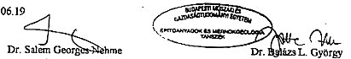

Project manager Head of the laboratory

* The additional documents are stored at the Test Laboratory of the Department Construction Materials and Engineering Geology, Technical and Economic University of Budapest
The test results are supposed to be valid for the tested samples.
Test records can be copied in its entirety!
№: I - 228 / 2007

TECHNICAL AND ECONOMIC UNIVERSITY OF BUDAPEST (МО: FI 23344)
DEPARTMENT OF CONSTRUCTION MATERIALS AND ENGINEERING GEOLOGY
CERTIFICATE OF COMPLIANCE OF THE TEST RESULTS OF RESISTANCE TO COMPRESSION OF CONCRETE ACCORDING TO MSZ 4798 - 1 : 2004

1. INFORMATION |  |  |  | No. of University
Customer: | PÓLUS KINCS ZRT  H-2132 Göd, Kádár utca 49 |  | Mark of the sample: I - 228 / 2007
Construction: | Test mixing  Technical and Economic University of Budapest, Department of Construction Materials and Engineering Geology |  | Storage of samples: mixed
Mark of the planned concrete | C30/37 - XC2, XA2 32/F2 | Age of concrete: | 28 days
Volume of the tested concrete: | ---- m³ | Nominal dimensions | 150 х 150 х 150 mm
 |  | Quantity: | 3 pieces

2. EVALUATION (Detailed test results can be found in the test record)
2.1. Evaluation of the density and the extant of the resistance to compression of concrete:
Requirements for the compliance of resistance to compression::
satisfactory
Requirements for the compliance of density:
satisfactory
The results of the resistance to compression can be evaluated for the appropriateness of the density and the extent of the resistance to compression.
2.2. Evaluation of the test results of the resistance to compression (test of identification according to Point В3.2. of the standard).
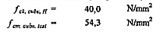Required value of the resistance to compression in case of mixed storage
Average of the measured values of the resistance to compression

1. condition:
Variety:
Permitted variety: (According to Point В2.1.3. of MSZ 4798 - 1 : 2004. standard)
satisfactory
2. condition:
satisfactory
On the basis of the test result the sample of concrete belongs to С30 /37 class of resistance to compression.

4. REMARKS
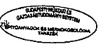
On the basis of the density of the samples the concrete belongs to the class of heavy concretes.

Budapest, 19th June 2007.
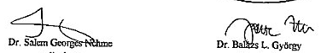
assistant professor - project manager teacher of university - head of department
Valid together with the test records №. I - 228 / 2007

TEST OF X-RAY DIFFACTION

TEST OF X-RAY DIFFACTION COMPLETED AFTER THE SORTING OF THE RAW MATERIALS OF THE REFUSE PILE OF RUDABÁNYA-II

completed on 20th June 2007.
The samples were taken from 83 places of sampling
by the Laboratory of the Environmental Protection of the Institute of Material and Environmental Chemistry of the Centre of Chemical Research of the Hungarian Academy of Science

Institute of Chemical Research of the Hungarian Academy of Science
TEST OF X-RAY DIFFACTION COMPLETED AFTER THE SORTING OF THE RAW MATERIALS OF THE REFUSE PILE OF RUDABÁNYA-II ON 20TH JUNE 2007.
The samples were taken from 83 places of sampling
MATERIAL OF THE FRACTION | QUARTZ | BARITE | DOLOMITE | COMPOUNDS OF IRON
DIMENSIONS OF THE FRACTION | / % / | / % / | / % / | / % /
smaller than 0.5 mm | 8 | 35 | 20 | 20
between 0.5 and 1.5 mm | 7 | 12 | 38 | 22,6
bigger than 1.5 mm | 8 | 8 | 48 | 22,6
The average is between 0.00 and 8 mm | 7,66 | 18,33 | 35,33 | 21,55

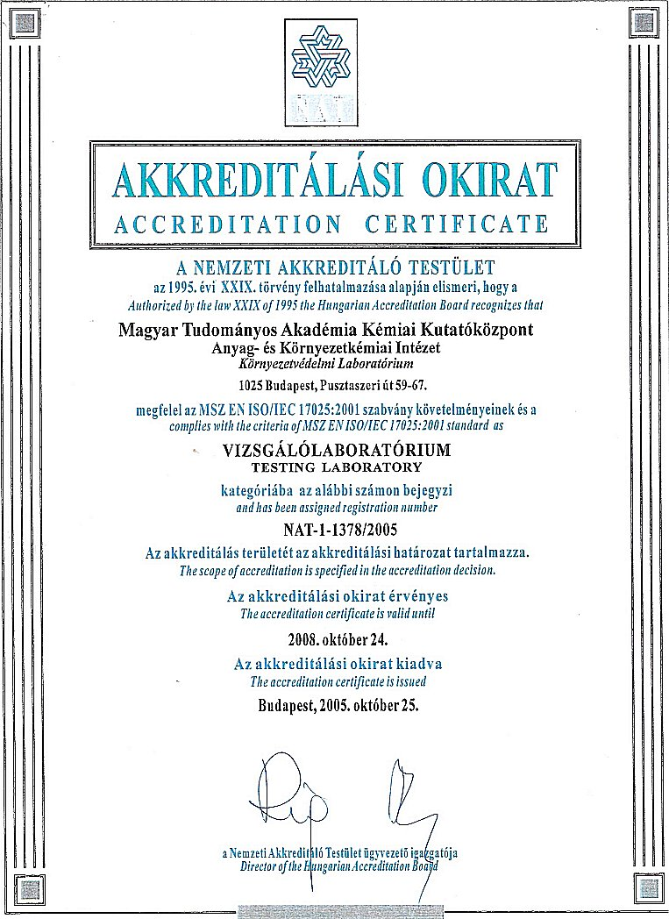

STUDY

on the tests of the additive of the refuse pile of Rudabánya-II called BARITMIX 1 required for the production of heavy concrete
by the Test Laboratory
of the Department of Construction Materials and Engineering Geology
of the Technical and Economic University of Budapest

TECHNICAL AND ECONOMIC UNIVERSITY OF BUDAPEST
DEPARTMENT OF CONSTRUCTION MATERIALS AND ENGINEERING TECHNOLOGY
Phone: (+36 - 1 ) 463-4068, (+36 - 1) 463-3452 * 1111 Budapest, Műegyetem rkp. 3. * Fax: (+36 - 1) 463-3450

OM FI 23344
Licence number at the University: 30547-003/05

STUDY

on the tests of the additive of the refuse pile of Rudabánya-II called BARITMIX 1 required for the production of heavy concrete

Customer: PÓLUS KINCS Zrt.
2132 GÖD Kádár utca 49.

Dr. Salem G. NEHME Dr. György Balázs L.
assistant professor - project manager teacher of university - head of department

Budapest, 29th August 2007.

1. INTRODUCTION

PÓLUS KINCS Zrt. has ordered a test of the additive of the refuse pile of Rudabánya-II called BARITMIX 1 required for the production of heavy concrete to be completed by the Department of Construction Materials and Engineering Geology of the Technical and Economic University of Budapest.

The tests cover the followings:

- The test of the raw material (dmax, grain-size distribution curve, fineness modulus, bulk density (loose and dense), density, bulk density, voids volume, water absorption and segregation)
- The features of the concrete made of the raw material (the features of the fresh and the concrete)
  - Placeability with spreading, the bulk density and shelf life of the fresh concrete
  - The bulk density, the resistance to compression, the frost-resistance and the sealing of the solid concrete
- The possibilities of the production of self-compressing concrete
- The radioactive tests
- the reaction between oxide of alkali metal and dolomite
- The summary of the findings

2. THE TEST OF THE ADDITIVE CALLED BARITMIX 1

The purpose of the test is to evaluate the different features of the sample of BARITMIX 1 delivered to the Department of Construction Materials and Engineering Geology of the Technical and Economic University of Budapest to be applied as heavy additive. The volume of the material to be tested is approximately 2 m³. The samples were taken by random sampling on the site by Dr. Salem Georges Nehme PhD., assistant professor and Mr. Írházi.

2.1. The tests of the raw material

The test of the additive: maximum grain size d_{max}, grain-size distribution, fineness modulus, density, bulk density, water absorption, segregation.

Visual inspection

The inspected material is a dark grey coloured grainy material with a high content of fine particles. Strong and white bleed can be found on the surfaces exposed to the effects of the weather. The grains have formed some a plenty of solid blocks of 10 - 20 cm for the material has been stored in the open air since 1989.

Maximum grain size:

The screening test of two different samples found that the dimension of the grains is less than 8 mm. (The total volume caught by the screen of 8 mm is less than 1%)

Screening test of the additive

The material was mixed thoroughly before the sampling and dried in a drying stove at 60 °C for 48 hours. The sample was tested by a standard screening line. The largest diameter of the grains was 8 mm. Two different m = 1,600 g samples were tested.
Evaluation of the fineness modulus
The grain-size distribution was tested again by the smallest screen of 0.063 mm. The way of sampling was similar to the way stated above.

Chart 1.: The findings of the screening test of the additive

d [mm] | Sample 1. caught weight [g] | Caught [%] | Passed  [%] | Sample 2. caught weight [g] | Caught  [%] | Passed  [%]
8 | 3 | 0,2 | 99,8 | 6 | 0,4 | 99,6
4 | 249 | 15,7 | 84,1 | 268 | 16,9 | 82,8
2 | 351 | 22,1 | 62,0 | 355 | 22,3 | 60,4
1 | 277 | 17,5 | 44,5 | 279 | 17,5 | 42,9
0,5 | 209 | 13,2 | 31,4 | 202 | 12,7 | 30,2
0,25 | 138 | 8,7 | 22,7 | 134 | 8,4 | 21,8
0,125 | 110 | 6,9 | 15,8 | 107 | 6,7 | 15,0
0,063 | 113 | 7,1 | 8,6 | 101 | 6,4 | 8,7
<0,063 | 137 | 8,6 | 0,0 | 138 | 8,7 | 0,0

The average value of fineness modulus calculated on the basis of the passed volume of material is: 4,35

The grain-size distribution curve of the additive (NHK 0/8 mm boundary curve); sample 1.

The volume passed the screen, %

Mesh openings, mm (log scale)

The tested material, m = 4.31

Boundary curve “A”, ma = 5.70

Boundary curve “B”, mb = 4.90

Boundary curve “C”, mc = 4.30

Figure 1.: the grain-size distribution curve of the sample 1.

The grain-size distribution curve of the additive (NHK 0/8 mm boundary curve); sample 1.

The volume passed the screen, %

Mesh openings, mm (log scale)

The tested material, m = 4.39

Boundary curve “A”, ma = 5.70

Boundary curve “B”, mb = 4.90

Boundary curve “C”, mc = 4.30

Figure 2.: the grain-size distribution curve of the sample 2.

Test of bulk density

The bulk density was tested by a cylindrical metal vessel of 1 litre. Two samples of 2 kg by each dried for 24 hours by the drying stove were tested by adding 2% (40 ml) water between the measures until the 10% water-content was reached. The samples were tested in compressed and in uncompressed condition. The compression was completed manually by beating for a period of 1 minute. The smallest bulk density of the uncompressed sample was detected at 8% water-content (1.314 g/cm³) and of the compressed sample at 4% (1.950 g/cm³).

Chart 2.: The values of bulk density of the uncompressed samples

Water-content [%] | 0 | 2 | 4 | 6 | 8 | 10
Sample 1. [g/l] | 1827 | 1797 | 1496 | 1362 | 1298 | 1307
Sample 2. [g/l] | 1866 | 1688 | 1484 | 1379 | 1329 | 1341
Average [g/l] | 1847 | 1743 | 1490 | 1371 | 1314 | 1324

Chart 3.: The values of bulk density of the compressed samples

Water-content [%] | 0 | 2 | 4 | 6 | 8 | 10
Sample 1. [g/l] | 2077 | 2068 | 1951 | 1956 | 2095 | 2176
Sample 2. [g/l] | 2034 | 2059 | 1949 | 1960 | 2082 | 2165
Average [g/l] | 2056 | 2064 | 1950 | 1958 | 2089 | 2171

The average value of the bulk density of the uncompressed sample is 1.847 g/cm³
The average value of the bulk density of the compressed sample is 2.056 g/cm³
Test of density
The density was tested by picnometer. The samples to be tested (3 pieces) were powdered and dried by the drying stove for 24 hours. The average value of the three tests makes 3,36 g/cm³.

Chart 4.: The finding of the test made by picnometer

Mark of the sample | Weight of the picnometer  (g) | Weight of the picnometer + powder  (g) | Weight of the picnometer + powder + water (g) | Weight of the picnometer + water (g) | Temperature of the water  (°C) | ρ_{water}  (g/cm³) | Density,  g/cm³
M1 | 48,1356 | 59,3161 | 112,313 | 104,438 | 25 | 0,997 | 3,3726
M2 | 43,4686 | 60,2724 | 108,5184 | 96,7767 | 25 | 0,997 | 3,3096
M3 | 61,2259 | 73,9078 | 174,589 | 165,6156 | 22,5 | 0,9976 | 3,4115
Average value: |  |  |  |  |  |  | 3,3645

Water absorption for a period of 24 hours
The sample of the barite was soaked into water for 24 hours and then the water was removed out of the grains. The weight of the sample was measured then the sample was put into the drying stove for 24 hours. The weight of the sample was measured after the drying as well. The volume of the absorbed water is 18.85%.

Chart 5.: The findings of the test of water absorption

m saturated [g] | 227,14
m dry [g] | 191,12
Δm [g] | 36,02
m_{v} [%] | 18,85

Segregation
A sample of 1,200 g was tested by the smallest screen of 0.125 mm. The weight of the part being bigger than 0.125 mm is 923 g (76.92%) and the weight of the passed part is 276 g (23.08%).

Total porosity
The total porosity of Baritmix 1 is 45.1 %.

The chemical test of the refuse of barite
Acid and water solution
White salting-out can be detected on the refuse pile of barite stored in the open air after drying. The purpose of the test was to detect any difference between the two parts of the sample by solution test, if any. The findings of the test can be seen in chart I.

Chart 6.: The oxide composition of the refuse pile of barite

Tested feature | Applied standard | Measured value
Tested feature | Applied standard | Brown coloured part | Part having white salting-out
Ignition loss, weight% | MSZ EN 196-2 | 21,20 | 30,89
Soluble with thin hydrochloric acid, weight% | MSZ EN 196-2 | 62,80 | 80,05
SiO₂ soluble with thin hydrochloric acid, weight% | MSZ EN 196-2 | 1,29 | 0,68

According to Chart 6. the part of the sample having white salting-out has more easily soluble components (the rate of the part soluble with thin hydrochloric acid, as well as the ignition loss are more) but has less content of silicate.

The bleed was supposed to be mainly of sulphate origin that’s why the content of sulphate of the homogenized part of the sample was detected by distilled water and acid solution. The different fractions separated by screening were tested separately for the solubility is influenced by the grain size. The findings of the test can be seen in Chart 7.

Chart 7.: The content of sulphate ion of the ground material of different grain size of the refuse pile of barite

The grain size of the tested fraction | Content of sulphate, weight %
The grain size of the tested fraction | Acid solution | Distilled water solution
< 0,125 mm | 1,00 | 0,99
0,125 - 1 mm | 0,74 | 0,66
> 1 mm | 0,43 | 0,39

It can be declared on the basis of the findings that more sulphate dissolves from the part of smaller grain size.

Derivatography test

Derivatogram was made on the sample having white salting-out can be seen in Figure 3. Gypsum (G) and dolomite (D) is supposed to be present according to the shot and it can be the reason of the high ignition loss.

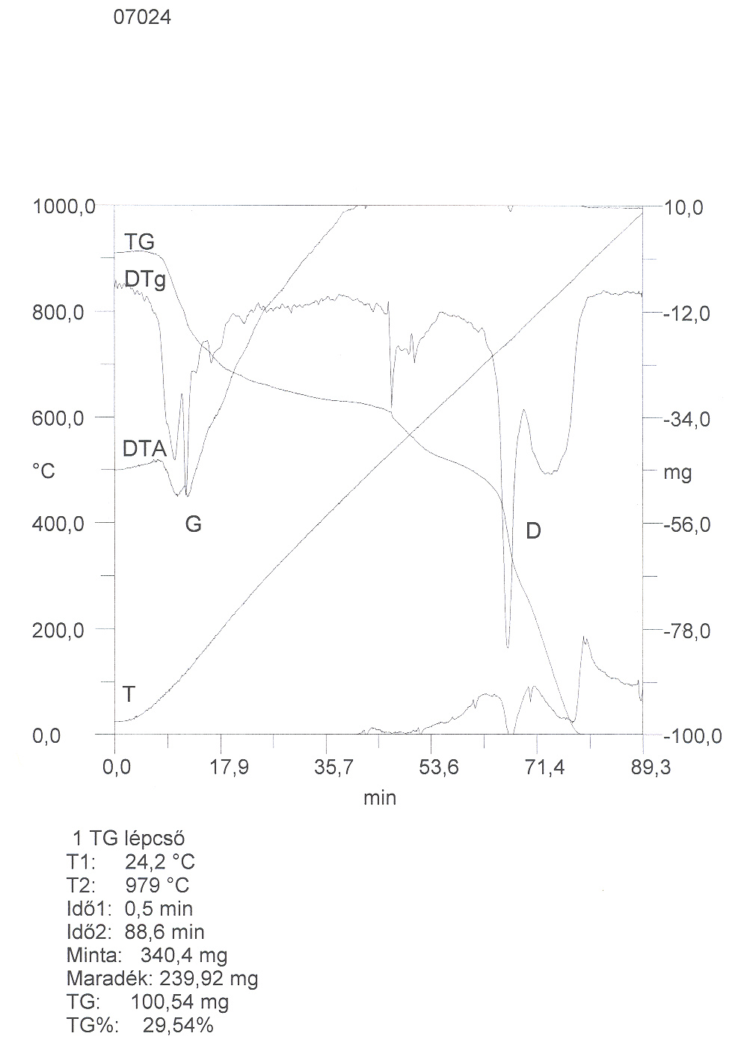
1 TG stage
T1: 24,2 °C
T2: 979 °C
Time1: 0.5 min
Time2: 88.6 min
Sample: 340.4 mg
Remainder: 239.92 mg
TG: 100.54 mg
TG%: 29,54%

Figure 3.: Derivatogram made on the part of the refuse pile of barite having white salting-out

Summary made on the tests of the raw materials

The tests above have found that the additive called BARITMIX 1 is not suitable to be the only raw material of the heavy concrete for its ability of water absorption and d_{max}. The fraction of sand can be substituted by it and the other rough fraction can be either basalt or any other mashed material with a bulk density of 2,7 g/cm³.

Further possibilities
The screening test has found that content of grains smaller than 0.5 mm is 30 - 31.5% making a “fine heavy material” being suitable to produce an especially heavy plaster of radiation protection. The rest of the material with the grain size of 0.5 - 8 mm can substitute the fraction of rough sand.

3. TEST OF CONCRETES MADE OF BARITMIX 1

3.1. The features of the fresh concrete

3 different formulations were made to test the features of the fresh concrete and the mechanical features and the ability of the radiation protection of the solid concrete.

Chart 8.: Mixture of concrete marked by N1
Material | Type or fraction |  | Weight, kg/m³ | Volume, l/m³
Additive | fraction of 0/6 mm  BARITMIX-1 | 65% | 1445 | 438
Sand | 0/1 mm | 5% | 89 | 34
Andesite | fraction of 5/12 mm | 15% | 285 | 101
Andesite | fraction of 11/32 mm | 15% | 285 | 101
 | Total | 100% | 2104 | 673
Cement | CEM I 32,5 |  | 400 | 129,0
 | Blast-furnace cinder |  | 20 | 8,5
Water | mw/mc = | 43,0% | 172 | 172
Additive agent cem. d% | Glenium 51 | 3,00% | 12,0 | 12
Air |  |  | -- | 5
Total |  |  | 2708 | 1000

Chart 9.: Mixture of concrete marked by N2
Material | Type or fraction |  | Weight, kg/m³ | Volume, l/m³
Additive | fraction of 0/6 mm  BARITMIX-1 | 60% | 1333 | 404
Sand | 0/1 mm | 5% | 89 | 34
Andesite | 8/11 | 5% | 95 | 34
Andesite | fraction of 11/24 mm | 30% | 569 | 202
 | Total | 100% | 2086 | 673
Cement | CEMI 32,5 |  | 420 | 135,5
 | Blast-furnace cinder |  | 20 | 8,5
Water | mw/mc = | 39,0% | 164 | 164
Additive agent cem. d% | Glenium 51 | 3,35% | 14,1 | 14,07
Air |  |  | -- | 5
Total |  |  | 2704 | 1000

Chart 10.: Mixture of concrete marked by N3
Material | Type or fraction |  | Weight, kg/m³ | Volume, l/m³
Additive | fraction of 0/6 mm  BARITMIX-1 | 60% | 1317 | 399
Sand | 0/1 mm | 5% | 88 | 33
Andesite | fraction of 5/12 mm | 10% | 188 | 67
Andesite | fraction of 11/24 mm | 25% | 469 | 166
 | Total | 100% | 2061 | 665
Cement | CEM I 32,5 RS |  | 400 | 129,0
 | Blast-furnace cinder |  | 20 | 8,5
Water | mw/mc = | 45,0% | 180 | 180
Additive agent cem. d% | Glenium 51 | 3,10% | 12,4 | 12,4
Air |  |  | -- | 5
Total |  |  | 2674 | 1000

Remarks: The fraction of 0/6 mm is a recyclable heavy (radiation protecting) additive called Baritmix 1.

The features of the fresh concrete are listed in Chart 11. The weight of two series of three cubic models of 15 size was weighed empty and full of concrete. The nominal bulk density of the fresh concrete = the difference of the weight / the nominal volume of the model (m/v).

Chart 11.: The features of the fresh concrete

Mark of the formulation | Average nominal bulk density  kg/m³ | Consistency: with surface measurement,  mm
N1 | 2599 | 55,5
N2 | 2578 | 52
N3 | 2544 | 64

The resistance to compression of the solid concrete
The values of the resistance to compression of the solid concrete are listed in Chart 12.

Chart 12.: The values of the resistance to compression of the solid concrete

Mark of the formulation | Average bulk density  kg/m³ | Average resistance to compression,  N/mm² | Characteristic value,  N/mm² | Mark of the concrete
N1 | 2630 | 54,28 | 45,4 | C30/37
N2 | 2599 | 59,3 | 50,4 | C35/45
N3 | 2585 | 55,9 | 47,1 | C30/37

The possibilities of the production of self compressing concrete

The first experiences got known all over the world were completed by Okamura from 1986, but the first prototype was made in 1988 (Okamura, Ouchi, 2003). The studies on the self compressing concretes, including theory of placeability were made by Ozawa and Maekawa at the Tokyo University (1989).

We would like to mention that concrete with the ability of self compression was made in Hungary before it. For instance, the 1 meter thick roof of reinforced concrete of experimental hall of the Institute of the Science of Construction at Szentendre was made of concrete requiring no vibration during 12 hours of permanent concrete placing in August 1976.

Levegő
Víz
Finom rész (cement + por)
Homok
Kavics
SCC
C
C: Traditional concrete; SCC: self compressing concrete

Air

Water

Fine component (cement + powder)

Sand

Pebbles
Figure 4.: The composition of the normal and the self compressing concrete V% (Okamura, Ouchi, 2003)

The principle of the self compressing concrete was determined by Okamura and Ozawa (1995) as follows:
- the determination of the required volume of additive: 50% of solid aggregate-volume,
- the determination of the volume of the fine additive: 40% for the mortar of the concrete,
- factor of water - fine component (cement + powder): between 0.9 and 1 according to the volume,
- application of additive having the ability of self compression.
Limited volume of pebbles

50 % of aggregate-volume

Appropriate mortar

Limited volume of sand

40% of the volume of mortar

Bigger shrinking

Moderate viscosity

Big dose of additive

Less w/c

Figure 5.: The phases of the planning of the compositions of the self compressing concrete by Okamura and Ozawa (Okamura, Ozawa, 1995)
The required volume of water is determined according to the proportion of the total volume of the cement and the grains of powder size which is between 0.9 and 1. It means that the volume of water shall be minimum 170 litres. That is, the volume of water required for the placing is more than the one of the concretes of high performance. But the air content of the fresh self compressing concrete is less than of the traditional concretes but there is no relevant change is the cement content of the self compressing concrete is at least 340 kg/m³.
The initial solidity of the self compressing concrete (2 and 7 days) is better than of the traditional concrete and it supports the faster scheduling and completion but does not support the scaffolding for its sensitivity to shrinking (the sudden increaser of the difference of the temperature and the quick evaporation). That is, the self compressing concrete can be cheaper for no energy of placing (compression) is required.

The test of radiation protection of concretes to be applied to store radioactive wastes

3 pieces of samples were made of each formulation. The samples were approximately 8 cm thick.
Furthermore, 2 pieces of samples were made of normal concrete for reference.
The tests were completed by Dr. Péter Zagyvai at the Institute of Nuclear Technology.

Applied test equipments: Radiation sources of ¹³⁷Cs and ⁶⁰Co types, positioning and spotting workbench, calibrated dose rate meter of FH40-G type

Period of test: from 13th July to 9th August 2007.
Marking of the concrete | Layer-thickness of halving [cm] in case of ¹³⁷Cs (gamma energy 0.66 MeV) | Layer-thickness of halving [cm] in case of ⁶⁰Co (gamma energy 1.25 MeV)
X.I. etalon | 5,73 ± 0,21 | 10,65 ± 0,63
X.II. etalon | 4,65 ± 0,15 | 8,11 ± 0,89
N1. (N1-1,N1-2, N1-3) | 3,87 ± 0,08 | 6,46 ± 0,41
N2. (N2-1, N2-2, N2-3) | 3,96 ± 0,08 | 6,81 ± 0,31
N3. (N1/3, N2/3, N3/3) | 4,10 ± 0,08 | 6,83 ± 0,55

Bulk density, kg/m³

Layer-thickness of halving, cm

Layer-thickness of halving (cm) in case of ⁶⁰Co
(gamma energy 1.25 MeV)

Layer-thickness of halving (cm) in case of ¹³⁷Cs (gamma energy 0.66 MeV)

The smaller is the layer-thickness of halving the more beneficial is the ability of the concrete to absorb (to attenuate the radiation). The data of the best sample are in bold. The relevantly bigger variation of the test completed with radiation source of ⁶⁰Co type is caused by the smaller source activity.

Dr. Péter Zagyvai
Institute of Nuclear Technology

Dr. Salem Georges Nehme, PhD
Department of Construction Materials and Engineering Geology of Technical and Economic University of Budapest

Exploitation of the refuse pile of Rudabánya-II

Study made by the University of Heavy Industry of Miskolc

The preparation and the complex exploitation of the material of the refuse pile at Rudabánya
Dr. József Böhm university docent, deputy dean
Dr. Barnabás Csöke university docent, head of department
Mr. Mihály Tassy grad. Mining engineer

Investigation on the preparation of the siderite ore

Precedents

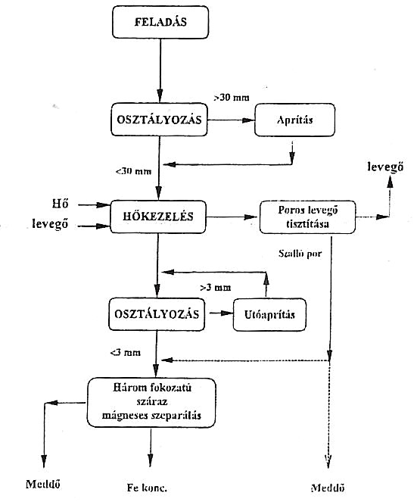Rudabánya was the only relevantly important mine of iron ore in Hungary after the World War I. until its stop in 1986. This area was featured by active mining activity for hundreds of years. Silver and non-ferrous metals were mined earlier and iron ore was produced after the World War II. The brown coloured oxidic iron ore (limonitic ore) was mined first and the carbonate (sideritic) ore was produced later. The oxidic ore did not require any preparation before the processing, that’s why the plant of preparation to process the carbonate ores was established in 1964. The simplified scheme of process can be seen in Figure 1.
FEEDING

SORTING
breaking

air

Heat
air
Cleaning of the
dusty air
HEAT TREATING

flying dust

SORTING
Secondary
breaking

Three-stage dry
separation
by magnet

Refuse
Refuse
Iron concentr.

Figure 1.: The simplified scheme of the plant of iron ore preparation at Rudabánya
The paramagnetic siderite containing the iron was transformed into paraferro magnetic hematite by heat treating during the preparation and it was fined by dry magnetic drum separator of weak field. The average iron content of 24 - 26% of the raw ore to be processed increased up to 46 - 48% for the treating. Beside of the iron content there were a relatively relevant volume of barite and copper sulphide, as well as some lead and zinc minerals in the edge zones of the ore body and in the filling material amongst the siderite crystals. These components got partly either into the concentrate or into the refuse during the treating. The barite broke relevantly during the heat treatment and got smaller than 1 mm or escaped with the flying dust. The smaller part of the separated flying dust got into the procedure of magnetic treatment while the bigger part got to the refuse pile directly. The average compound of the refuse originating from the magnetic separation and the heat treating of the raw ore to be processed can be seen in Chart 1.

component | Compounds [%]
component | Raw ore | Tailings | flying dust | Tested sample
Fe₂O₃ | 2 - 5 | 3 - 6 | 20 - 35 | 6,65
FeO | 25 - 30 | 6 - 7 | 4 - 8 | 15,42
CaO | 6 - 8 | 15 - 20 | 8 - 12 | 18,13
MgO | 8 - 10 | 6 - 8 | 6 - 8 | 7,60
Al₂O₃ | 2 - 4 | 0,6 - 0,8 | 2 - 4 | 0,70
MnO₂ | n. a. | n. a. | n. a. | 1,28
SiO₂ | 5 - 10 | 8 - 10 | 10 - 12 | 9,78
BaSO₄ | 5 - 10 | 10 - 15 | 22 - 28 | 17,90
Össz. Fe | 20 - 30 | 8 - 12 | 20 - 25 | 12,10
Fe²⁺ | 18 - 22 | n. a. | n. a. | 7,45
Mn | 0,5 - 1,5 | n. a. | n. a. | 0,81
Cu | 0,1 - 0,2 | 0,1 - 0,2 | 0,2 - 0,3 | 0,123
Pb | n. a. | n. a. | n. a. | 0,06
Zn | n. a. | n. a. | n. a. | 0,07
Ignition loss | 25 - 30 | n. a. | n. a. | 22,44

Chart 1.: The average chemical compound of the ore, tailings, flying dust and tested sample originating from Rudabánya

The relevant volume of refuse and tailings was piled up during the hundred years of operation of the mine. The total volume is supposed to be 100,000 - 150,000 kilotons covering an area of approximately 250 hectares. The area was partly recultivated by covering the refuse piles after the stop of the production.
2. Former intentions to exploit the refuse

Some experiences were made to exploit the barite and non-ferrous metal content of the refuse during the operation of the plant but they failed for the quality of the products and the economic reasons. The barite content of the refuse was supposed to be applied for deep-hole drilling, the paper industry and paints production but the quality of the concentrate deriving from the process of flotation was not appropriate. The appropriate quality required the application of chemical decolouration and thermal desorption but the process turned out to be too expensive. The preliminary heat treatment of the ores was problematic during the process of flotation of the non-ferrous metal minerals and the quality of the produced concentrate was not appropriate. That’s why the exploitation of the refuse was not possible earlier. The financial supports given to solve the problem of the environmental protection of the area, as well as the intentions of the investors provided the chance to repeat the investigation on the exploitation of the refuse, mainly of the tailings of Rudabánya.

3. New investigations on the exploitation of the refuse of Rudabánya

The new investigations on the exploitation of the refuse had the purpose to find the ways of application of the iron and barite content meeting lower quality requirements or the application of the material for construction. The only requirement was that the application shall cover the total volume, if possible. The other requirement was to provide some profit for the entrepreneurs and the investors during the exploitation resulting the solution of the questions of the environmental protection.

The investigation covered the followings:
- sampling on the site to learn the composition of the refuse piles
- screening test to determine the grain size
- determination of the chemical composition and the material content
- determination of the applicable components
- tests of separation by hydrocyclone
- determination of the basic curve of magnetic treatment
- experiment on wet magnetic separation of weak field

Sampling on the site:

The sampling was completed on the site. Approximately 150 kg sample was taken for the laboratory tests by core drilling in 4 - 6 m deep at five places of sampling. The completed sampling was not enough for the qualitative and quantitative survey of the refuse piles. It can be made after the successful investigations on the exploitation but the provided sample was appropriate for the laboratory tests.

Determination of the grain-size distribution:

The findings of the wet screening tests and the density of the different fractions can be seen in chart 2. The grain-size distribution can be seen in Figure 2.

Laboratory test I. of the refuse pile at Rudabánya

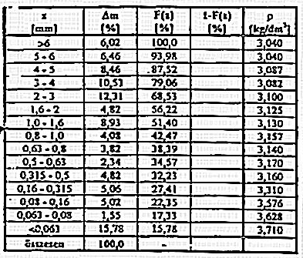
Total

Average density: 9,232 kg/dm³

Basic test of magnetic separation:

The sample was broken into a grain size less than 2 mm for the basic test of magnetic separation by a breaker having insert hammer. The fraction of the grain size of 0.25 - 2.0 mm (53.4% of the crushed material) was separated under increasing magnetic field intensity by dry cylindrical magnetic separator of Mechanobr type. The part of a grain size less than 0.25 mm (46.6%) was treated by wet magnetic drum separator of weak field. The composition of the separated materials and the findings of the test completed by Mechanobr separator can be seen in chart 3. The findings of the separation completed by wet magnetic drum separator can be seen in chart 4.

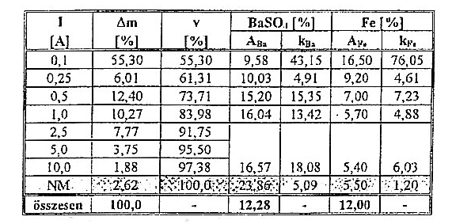
Total

Chart 3.: Findings of the dry magnetic separation of the refuse of Rudabánya

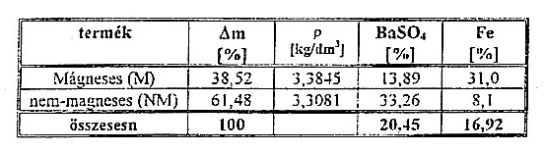
Product

Magnetic (M)
Non-magnetic (NM)
Total

Chart 4.: The findings of the test made by wet magnetic drum separator of weak field

No further selective breakage was caused by the breaking according to the findings of the test of the fractions of different grain size made by a breaker with hammer. But relevant selective breakage caused by the former technology of preparation was detected during the determination of the chemical composition of the fractions of the original grain size of the refuse. The composition of the refuse originating from the treatment of the iron ore can be seen by size and origin in the chart 5.

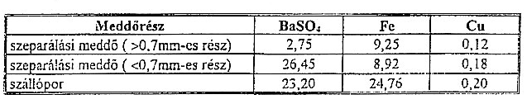
Type of refuse
Refuse of separation (>0.7 mm)
Refuse of separation (<0.7 mm)
flying dust

Chart 5.: Composition of the refuse originating from the process of treatment of iron ore by dimensions

